Project Report Template

CRM APPLICATION FOR SCHOOLS / COLLEGES

**1 INTRODUCTION**

This Project helps you to maintain and manage the school related problems which further can be modified based on the requirements.

**1.1 Overview**

The project aim is to provide real-time knowledge for all the students who have basic knowledge of Salesforce and Looking for a real-time project. This project will also help those professionals who are in cross-technology and want to switch to Salesforce. With the help of this project they will gain knowledge and can include it into their resume as well. .

**1.2 Purpose**

MAINTAIN AND MANAGE THE SCHOOL/COLLEGE RELATED PROBLEMS.

**2 Problem Definition & Design Thinking**

**2.1 Empathy Map**

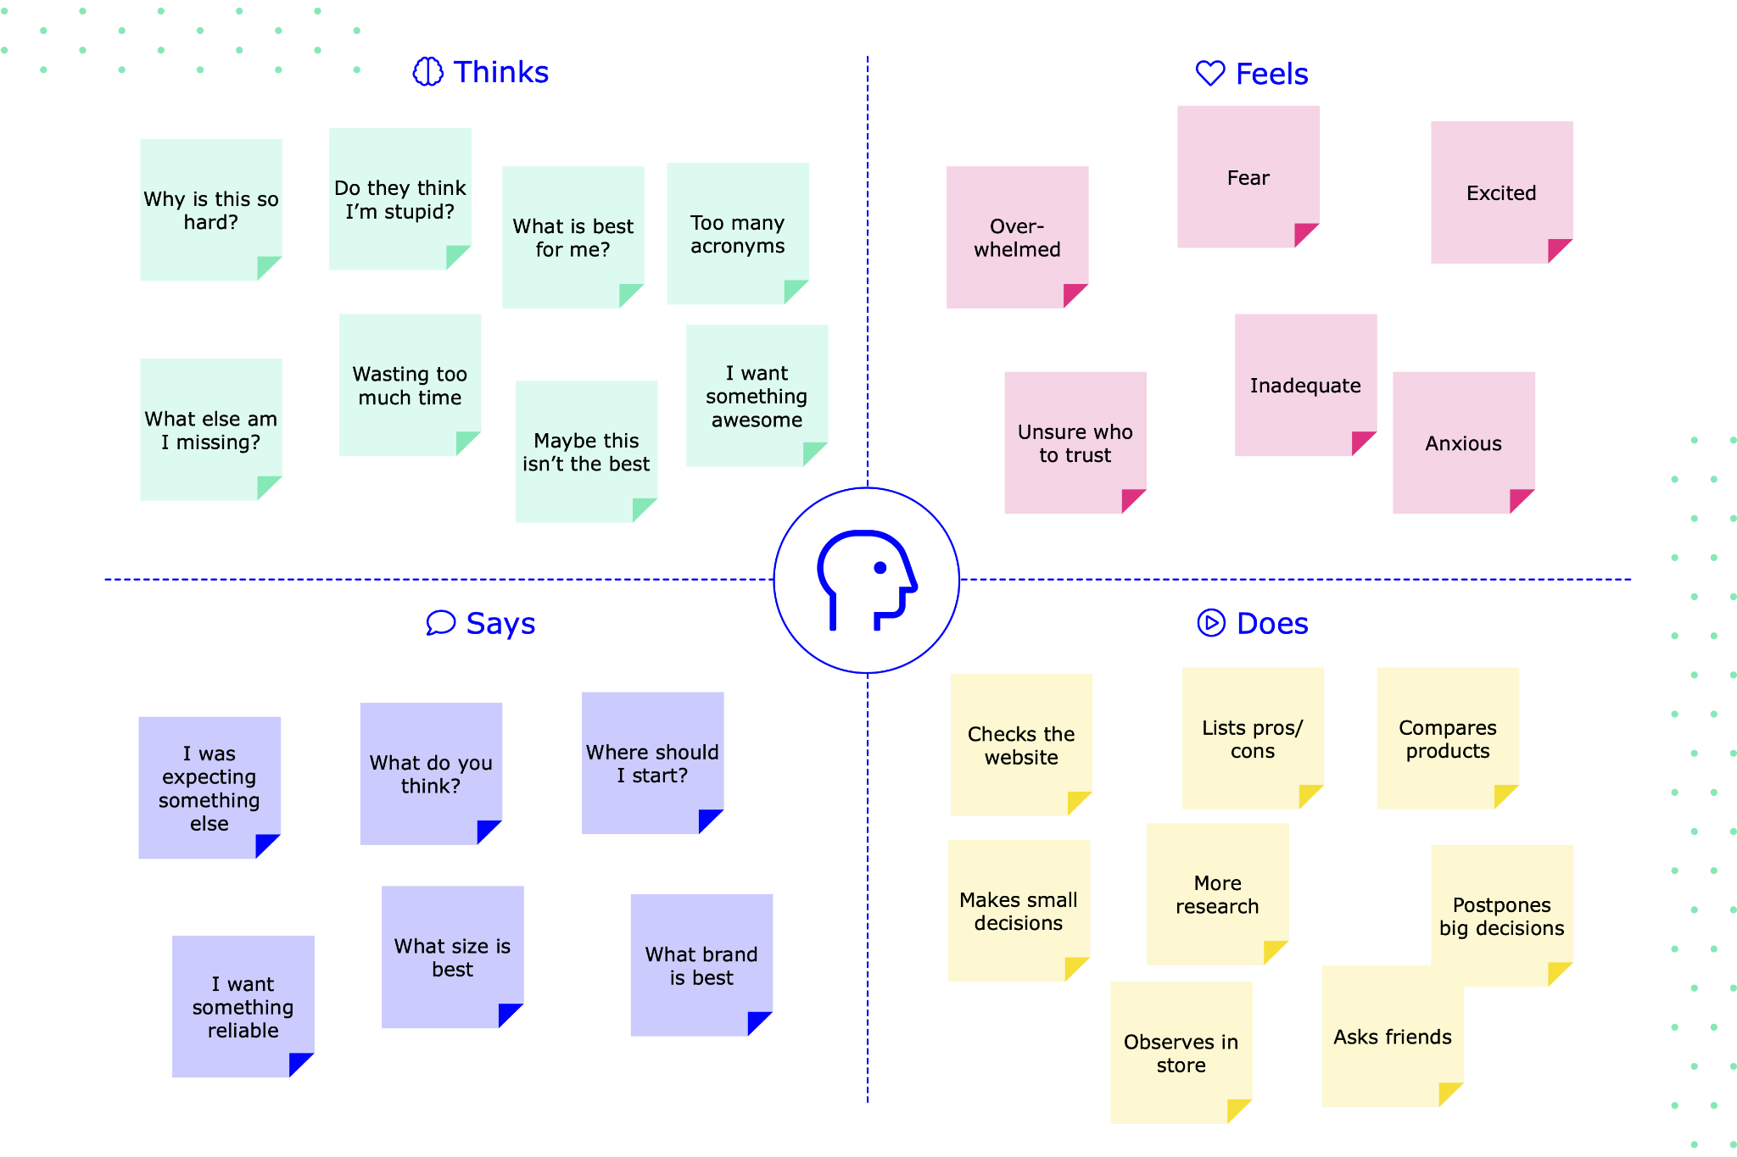

**2.2 Ideation & Brainstorming Map**

**A)**

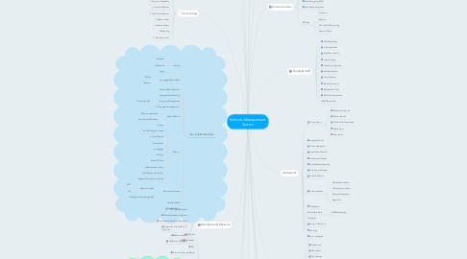

**B)**

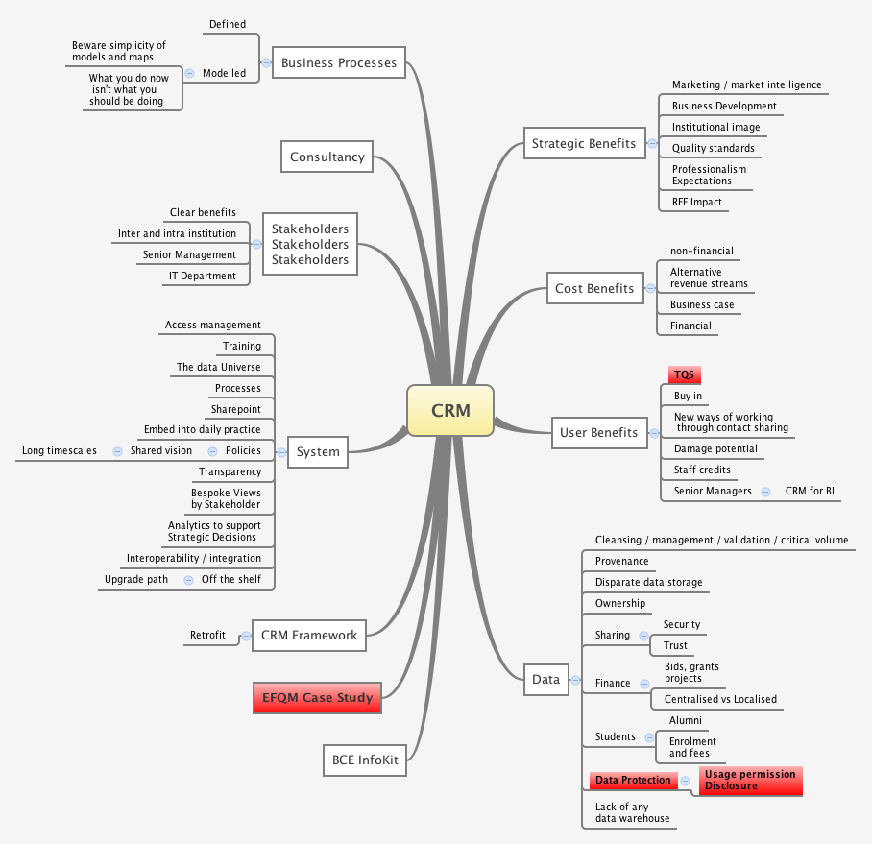

**3 RESULT**

**3.1** Data Model:

| **Object name** | **Fields in the Object** |
| --- | --- |
| Obj1    **PARENT** | Father : RAMAR  Mother : RAMUTHAI |
| **Obj 2**  **STUDENT** | SANTHOSH |
| **Obj 3**    **TEACHER** | PONMANI |

**3.2 Activity & Screenshot**

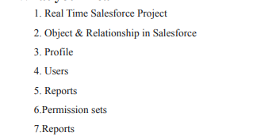

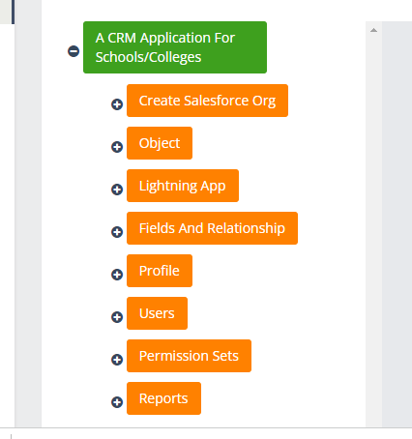

**4 Trailhead Profile Public URL**

**Team Lead - https://trailblazer.me/id/subas0702**

**Team Member 1 - https://trailblazer.me/id/skrishnan0509**

**Team Member 2 - https://trailblazer.me/id/rajesh0802**

****Project Report Template

**5 ADVANTAGES & DISADVANTAGE**

**ADVANTAGES**

* **Improve Student Admissions Lifecycle. ...**
* **Track Student Life-Cycles Within the Institution. ...**
* **Keep Alumni Information Safe and Accessible.** ...
* Stay Connected with Teams. ...
* Monitor Fee Payments and Reminders. ...
* Track and Gain Insight on Organization-Wide Data and Processes. ...
* Reduce Operational Costs.

DISADVANTAGES

* Burdensome data entry. ...
* Dependent on proper set-up. ...
* Focused on the wrong person. ...
* Cost. ...
* Without a solid process, it's pointless. ...
* Data entry can be automatic.

**6 APPLICATIONS**

**Applications of a CRM – Examples and Strategies.**

**Application 1: Tracking Customers.**

**Application 2: Collecting Data for Marketing.**

**Application 3: Improving Interactions and Communications.**

**Application 4: Streamlining Internal Sales Processes**

**7 CONCLUSION**

Result for conclusion for crm in schools

The work experiences I encountered during the internship allowed me to develop [specific skills]. I think I still require to work on my [mention other skills]. But, the overall experience was positive, and everything I learned would be useful in my future career in this field

**8 FUTURE SCOPE**

Customer relationship management (CRM) is the combination of practices, strategies and technologies that companies use to manage and analyze customer interactions and data throughout the customer lifecycle. The goal is to improve customer service relationships and assist in customer retention and drive sales grow